
Company
Logotype

Cone Beam Computed Tomography- Report



Porur Dental X-rays & CBCT

Patient Name : Mr. Manimaran | Date of Report : 23.10.2024
Age/ Gender : 40 years/ Male | Region of Interest : CBCT Sectional Mandible
Referring doctor: 32 Dental | Indication : Pain in relation to right lower quadrant
Clinical Notes: Nil
PATIENT INFORMATION

CBCT- Sectional Mandible provided
CBCT – IMAGE DETAILS

RADIOGRAPHIC INTERPRETATION

- In relation to 47, presence of a thin hypodense line, extending from the occlusal aspect upto the lingual portion is evident. Though the hypodense line does not seem to involve the lingual portion completely, it is evident in almost all sagittal sections that involve the tooth 47 and also appears to involve the pulp of 47.
- In 47, presence of periodontal ligament space widening in the apical region is also evident.
- Mesially tilted tooth 45 with its crown place lingual to 44 is evident.
- The alveolar bone in relation to 46, 47 is present with normal trabecular pattern.

RADIOGRAPHIC IMPRESSION

- Crown fracture in relation to 47.

Kindly correlate with clinical findings


IMAGES FOR REFERENCE

RECONSTRUCTED PANORAMIC VIEW

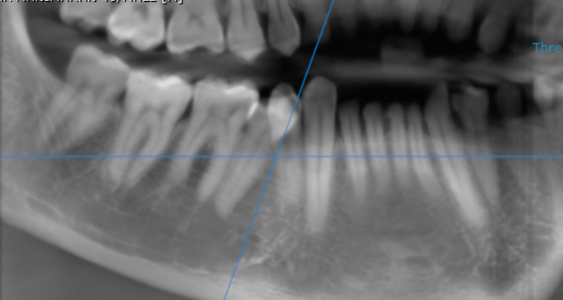

3-DIMENSIONAL VIEW

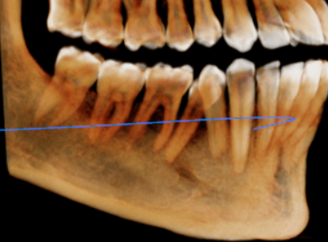

CROSS SECTIONAL VIEW
Hypodense Fracture line

47 region | 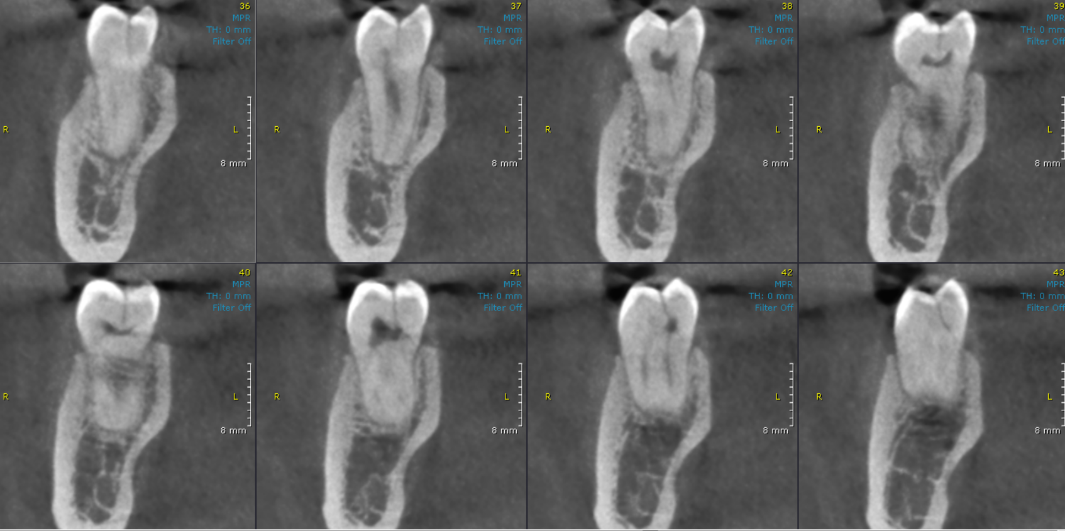

**** End of report ****

